PRODUCTIVITY TOOLS

Rapportive:
What is Rapportive?
It is a Google Chrome plugin app owned by LinkedIn, connecting your LinkedIn with gmail account.
What it does?
It shows you everything about your email contact right inside your inbox. You can connect with any one of them by just one click.
It is available on www.rapportive.com
Benefits of Implementation?
- By using rapportive with your gmail account we can see whether the candidate is one of our LinkedIn connections or not if not we can send connection request to them.
- We can also see the relevant information of the candidate (like his current designation, the name of the company, location) also we can see what are the other social media platforms on which the candidate is available, common connections etc right from our inbox.

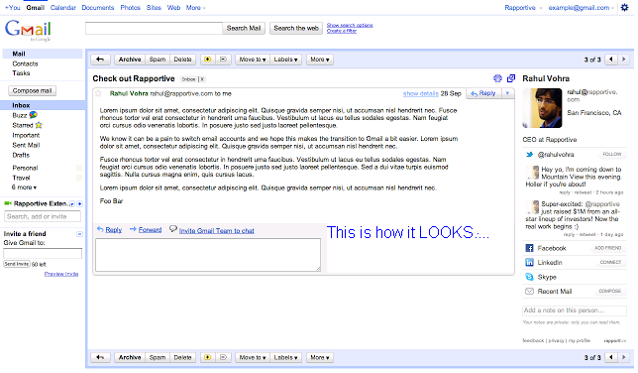

PROPHET:
What is Prophet?
It's a Google Chrome plugin, you install it on your Chrome browser, and navigate to any person's social networking profile--LinkedIn, Facebook, Twitter. Prophet sits on the sidebar and is available when you want and need it.
It is available on http://www.crx4chrome.com/crx/11953/
What it does?
It uncover emails, phones and other social sites for most any social profile. Prophet goes beyond what can be found on the web by using an advanced engine to predict and verify contact information.The email addresses come in several varieties:
[Verified] The email exists, is deliverable
[Unverified] The email exists, is probably deliverable
[No email could be guessed] All known as nonexistent or undeliverable
Benefits of Implementation?
- By using Prophet the recruiter can get most likely email address and phone no of the candidate and can start communicating with them.
- Recruiter can get candidate’s links to their other profiles or personal websites which can help the recruiter to understand the professional background of the person.

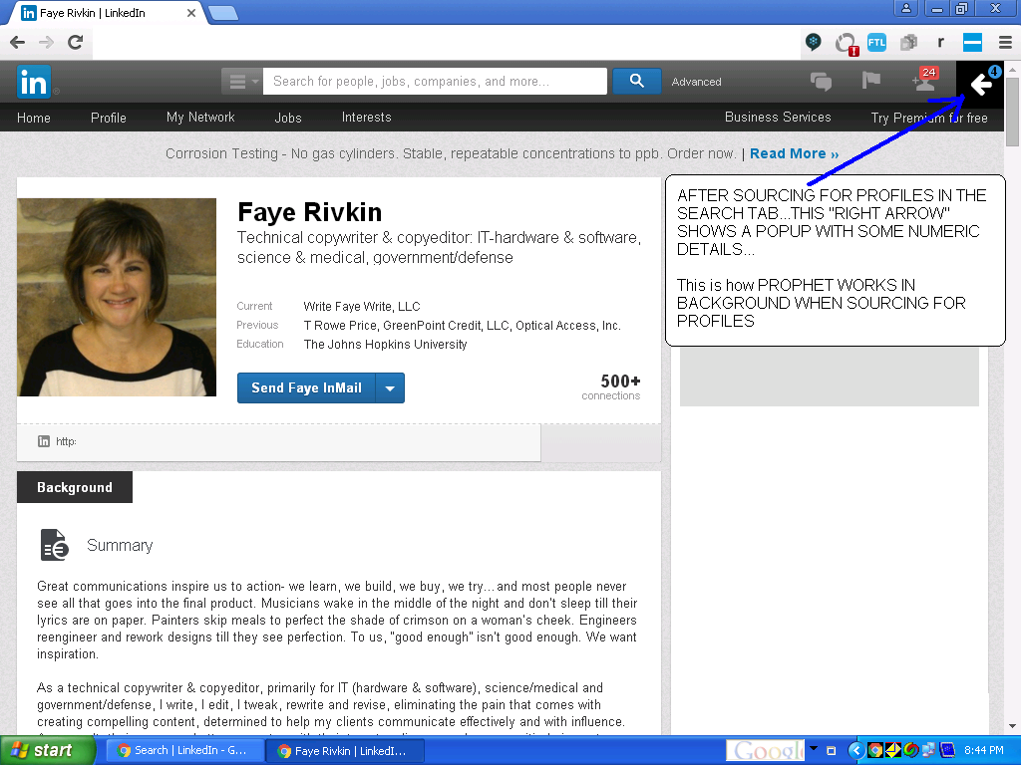

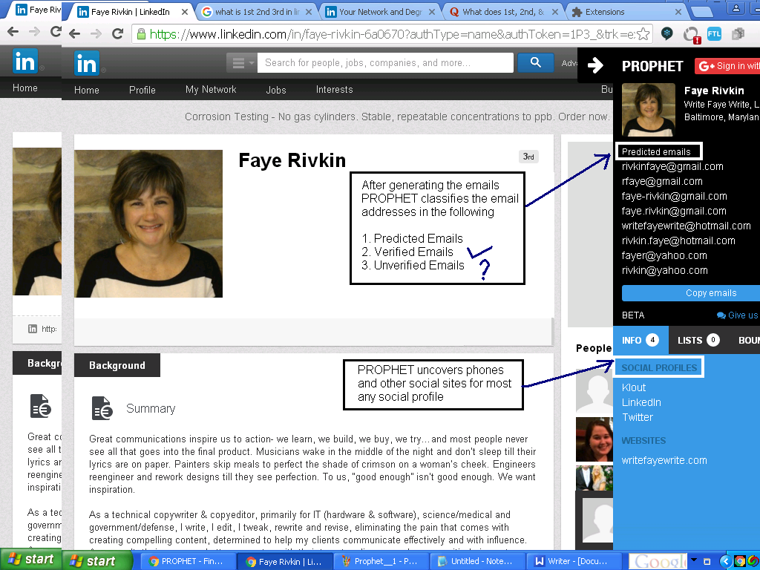

SIDEKICK:
What is sidekick?
It is a plugin by Hubspot for your Outlook, Apple mail or Gmail, it lives in your browser and works continuously in the background, Sidekick updates information in real time.
It is available on www.getsidekick.com
What it does?
With the Sidekick Outlook plugin, you can track emails directly within Outlook. Sidekick adds a simple checkbox to the top of Outlook to let you choose which emails you want to track. Combined with Sidekick's Chrome extension, you can get instant notifications when an important contact clicks or opens one of your emails.
Benefits of Implementation?
- Recruiter gets notified in real time when their emails are opened or attachments or links are clicked which gives them idea about the interest level of candidate.
- With Sidekick, recruiters not only get access to the tools Signals provided, but they also will automatically see a popup window in Gmail to compose their emails.

CRYSTAL KNOWS:
What is Crystal knows?
Crystal is a Chrome extension that analyses public data to tell you exactly how to communicate with different individuals. And it does so with startling accuracy.

It is available on bit.ly/crystalknows

What it does?
Using personality detection technology, the Crystal Chrome extension creates unique personality profiles for every person with an online presence, to show you how to speak/write in their natural communication style.
Benefits of Implementation?
- Crystal creates unique personality profiles for people with an online presence, preparing recruiters to speak or write in their candidate’s natural communication style.
- It helps recruiters in building healthy and productive relationships by understanding the personality of candidate they are communicating with.
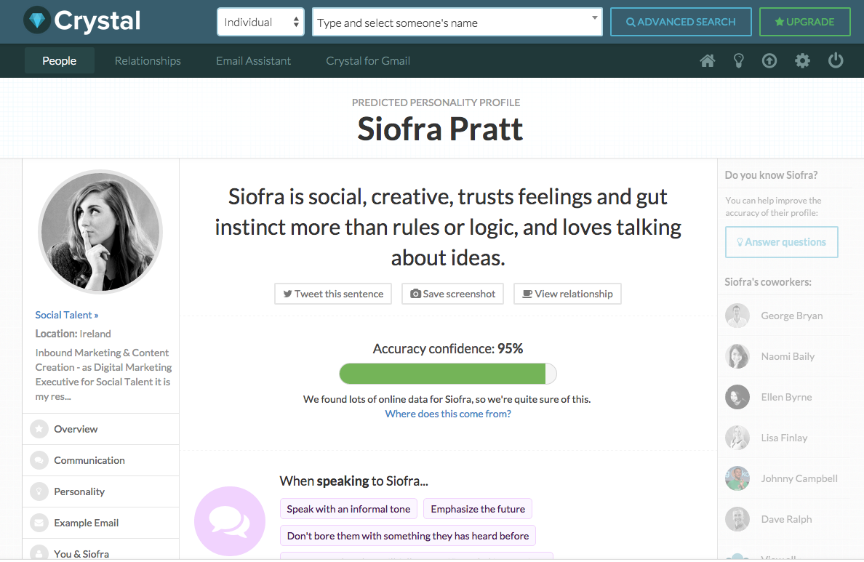

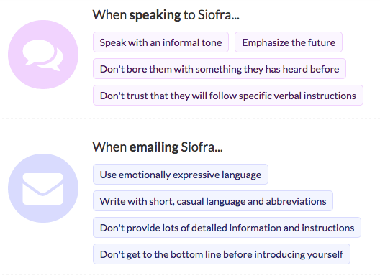

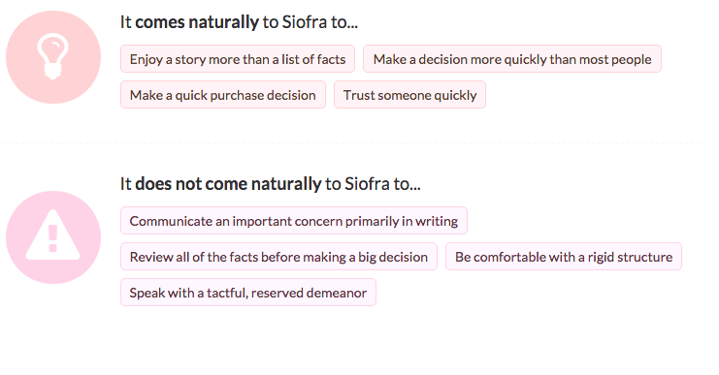

* *All the above mentioned productivity tools can be applied only on laptop/desktop not on phones.**

